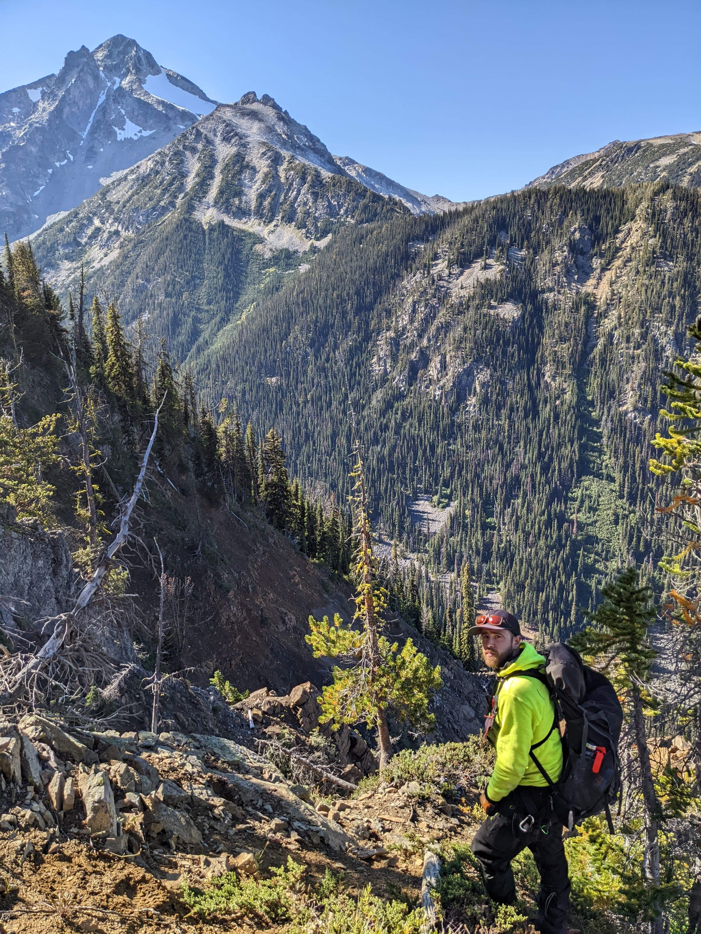 |  | Trevor Ridley  Crew Leader, Field Technician
Profile  Want to put your own image in the circle? It is easy! Select the image and do a right mouse click. Select “Fill” from the shortcut menu. Choose Picture… from the list. Navigate your computer to get the appropriate picture. Click okay to insert your selected image.  Once your image has been inserted, select it again. Go to the Picture Tools Format menu. Click on the down arrow below “Crop” and select “Fill” from the list. This will auto adjust your image to crop to the image. You can click and drag your image to place it appropriately.  Contact  Tridley2112@hotmail.com  1 250 961 3072  678-555-0103  WEBSITE:  Website goes here  EMAIL:  Hobbies  Hobby #1  Skateboarding  Snowboarding  Hiking/Backpacking  Novice climbing.  I enjoy all things adventure sports.  Hobby #3  Hobby #4 |  | WORK EXPERIENCE  Discovery Intl Geophysics. Crew Leader  August 2018–Present  TEM and 3DIP survey work. Extensive experience with a multitude of different geophysical systems, including but not limited to: Fixed loop, Moving loop, stepwise moving loop. SAMSON, Jessy Deep SQUID, HeliSAM. Mostly operating in mountain and arctic environments.  [Company Name] [Job Title]  [Dates From]–[To]  [Describe your responsibilities and achievements in terms of impact and results. Use examples but keep in short.]  High Mountain Seismic Ltd. Faller  August 2014 – August 2018  Danger tree faller, slasher. Certified ENFORM faller.  Hendex Exploration Ltd. Line Cutter  August 2009–August 2014  Line cutting, soil sampling. Seismic slasher, Mountain pine beetle probing and burning.  Happy Creek Minerals. Field Technician  August 2007- August 2009  Soil sampling, Line cutting, contour sampling, chip sampling, trenching, drill core processing and sampling, Geotech.  Description  Ive spent most of my life in a wilderness setting for work and play. I have extensive field experience in the mining exploration industry. I have dabbled in the seismic, silviculture and foresty sectors as well. I am currenty looking for a new opportunity within the natural resource industry. I was born in Ontario and lived in BC for 16 years. I am currently located in Saskatoon with plans to move back to BC this year. I’m 34 years old.

