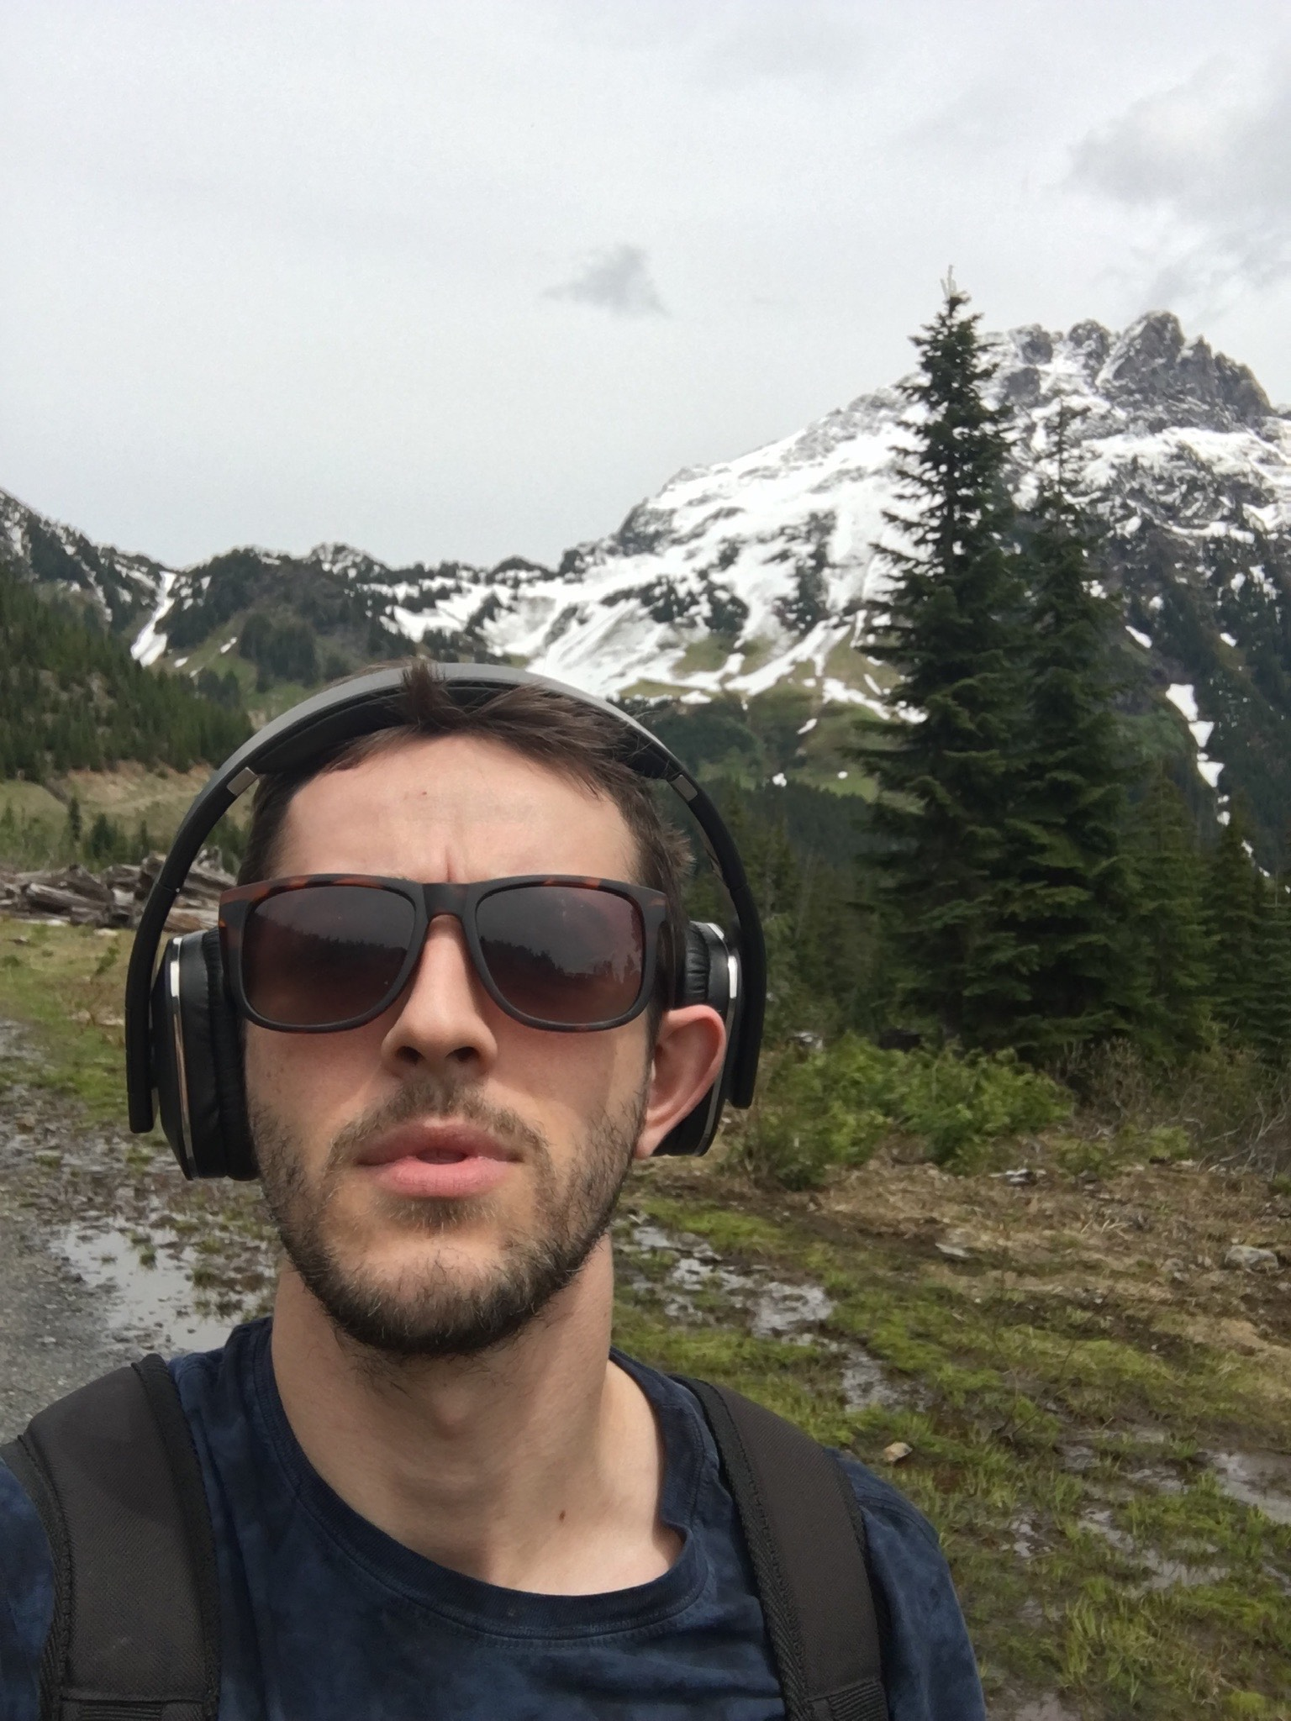
Jonathan Carroll #23 1434 Davie st, Vancouver, BC, V6G 1V4
778 384 9489 jonnymanchetser22@gmail.com
_____________________________________________________________________________

Overview:
Motivated, 29-year-old, professional adult, recently graduated from the Geological Resources Diploma at Douglas College. Born in Manchester, England then emigrated to the Centre Region of France during my adolescence, allowing the development of a fierce independence and natural curiosity with a passion for environmental sciences and geology. Graduated from both French & Canadian high school.

Education & Technical skills:

Douglas College – Geological Resources Diploma Program (2019-2024)
-courses included, History of the Earth, Sedimentology & Stratigraphy, Intro to Mineralogy, Intro to Petrology, Structural, Geological mapping, Geological-Information-systems, Field school. Taught by highly qualified professional instructors about industry techniques such as, optical mineralogy, three-point-models, contouring, ore deposit/resource exploration and mining, Arc-Pro & ESRI, Sequent, as well as field work and core tecking.

Employment History:

- Bureau Veritas: Geochemical analysis lab, Vancouver; (Sample Prep Tech) May 22 – Sep 22
-Responsibilities included preparing rock samples for testing, operating heavy machinery and attention to detail, ensuring samples met the companies and client’s quality expectations and guaranteeing the sample were adequate for the appropriate analysis. Quickly advanced and excelled in other areas of the sample prep department such as the high-grade metals & precious minerals analysis (or 'metallics') as well as soils and international soils prep.

- Spence Diamonds: Diamond jewelry retailer, Vancouver; (Front desk administration) 19- 2021
-Worked in a professional, high-profile environment. Responsible for handling all payments, inquiries, appointments, scheduling and/or organising repairs, inspecting, and cleaning of the merchandise, as well as assisting the sales consultants in the showroom. Regularly interacted with customers and helped resolve issues with purchases or other various customer service concerns. Led the weekly inventory counts and ensured all products were accounted for and in perfect condition, while in direct and constant communication with head office, if any discretions were to be discovered, to adjudicate the situation.

- S+L steak and lobster house: JRG Restaurant, Langley; (Prep cook/Night coach) 18- 2019
-Hired on as a morning salad/veg prep, responsible for most of the ‘fresh’ cuts in the restaurant, salad station preparation, and dessert prep. Moved into a kitchen manager position shortly after and became accountable for all Back of House evening duties. This included setting up for the nightly service, ensuring product/equipment quality (counts, temp logs, upkeep, etc.,) evening scheduling, supervising, and running a team of 9-15 people, assisting servers and other managers with guest issues and allergy concerns, maintaining sales and a healthy profit/labour rate, organising training, as well as delegating menu updates to the rest of the restaurant or generally assisting the team where/when needed.

- Epic Restoration: Flood restoration, Port Kells; (Flood/water tech, general labourer) 16-2019
-Started as a general labourer & completed my water damage restoration ticket (IICRC) and began running my own jobs. Assisted and completed asbestos abatements, multi-unit flood claims, mould remediation, and large-scale fire clean-up, as well as controlled demolition and restoration/renovation repair jobs. Worked in the Contents department cleaning, packaging, and moving customers furniture and personal belongings. Lots of heavy lifting, walking, and 24hr on-call emergency service.

Jonathan Carroll #23 1434 Davie st, Vancouver, BC V6G 1V4 ~ 778 384 9489 ~ jonnymanchetser22@gmail.com
_________________________________________________________________________________________

Volunteering:

Kormilda College – Darwin, Australia (2012-2013) - 10 months volunteering at a boarding school, teaching French to grades 9-12. The program also included working in the boarding houses as a ‘Camp Counsellor,’ driving students to appointments, helping with homework, or assisting with the dinnertime meal prep and stock orders, along with trips to isolated indigenous communities in the Australian outback to offer aid or youth education.

Skills & Hobbies:

- I am a dedicated and hard worker, able to handle high stress situations, keep a clear head, and skillfully improvise in many ways to complete the designated tasks.

- I have always been a fast-paced learner and my ability to identify and adapt to varied skills or information efficiently and swiftly have given me the ambition to succeed and grow within an enterprise.

- I have excellent customer service skills and can hold a polite, intelligent conversation.

- I am fair, honest, and possess great leadership skills. I pride myself on my work ethic, dedication to the tasks at hand, punctuality, and a thirst for knowledge.

- I speak fluent French, basic Spanish, and ‘Duolingo’ Russian; I am continuously adding to my repertoire of abilities. For me you can never stop learning.

- During my time at Douglas College, I was able to attend several workshops that taught industry specific tools such as a Core Tecking workshop hosted by Fireweed metals and a sample prep analysis workshop by Wheaton Precious metals. Completed multiple lessons on Leapfrog, Sequent, QGIS, ArcMaps and ArcPro for techniques on Geomodelling of reserves and resources and generated maps or drillhole log models.

- AED/CPR/Injury & Universal precaution Field First Aid (Adult/Infant/Choking), Class 7 Driver’s licence, previously completed Bronze Cross and Bronze medallion lifeguard courses.

- I enjoy reading, listening to music, cooking, geology, history, and hiking, I have several spots in the lower mainland that I often frequent with fellow friends to dig for precious minerals or explore for new locations.

References:

- Dr. Derek Turner, Ph.D., P.Geo, Quaternary Geologist and Geoscience Educator, Chair, Earth and Environmental Science, Douglas College email: turnerd1@douglascollege.ca

- Nathalie Vigouroux, Ph.D., Volcanic igneous geologist and Educator, Earth and Environmental Science, Douglas College email: vigourouxcaillibotn@douglascollege.ca

